CSCE 5580: Computer Networks

Programming Assignment 2

Due: 11:59 PM on Friday, March19, 2021

Programming Language Used for Development: Python

Files Uploaded: portScan.py

Command to run the python file:

python filename.py

The program scans port from a low to a high value specified by the user

Input : portScan <hostname> <protocol> <portlow> <porthigh>

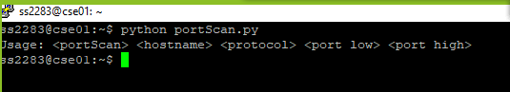



Scanning TCP ports from 1 to 120

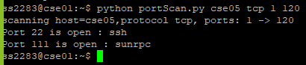

Scanning UDP ports from 1 to 30

